Daily Tarot App
Proposal

This app gives registered users a daily fortune based on traditional tarot card readings.

Wireframes
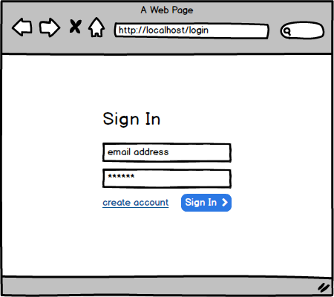
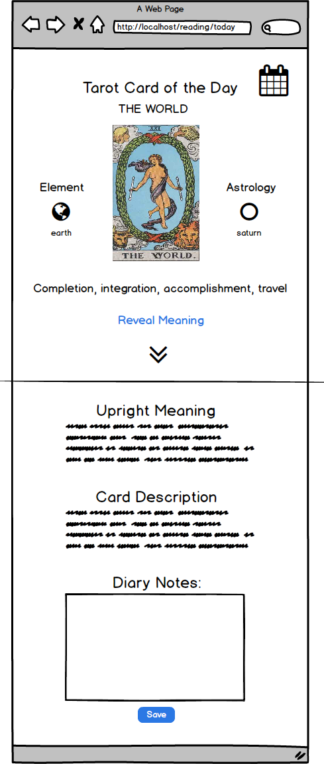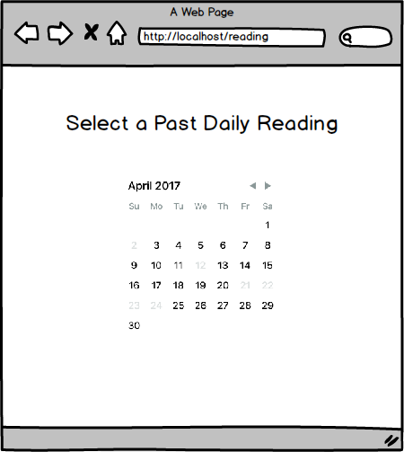

MVP

- The app only draws cards for registered users.
- Only one tarot card is drawn per day and saved to a user’s history.
- The reading includes in-depth explanations for a card in the upright or reverse position.
- The user can save a diary entry at the end of each day if they want to record their progress.
- The user can recall their past readings using a calendar
- DB design allows for phase 2 updates to integrate easily

Phase 2

- Ask for a reading based on a question
- Allow for multi-card spreads like the celtic cross.
- History based on question
- Glossary of cards
- Allow user to choose their preferred deck design

